Matrix operation

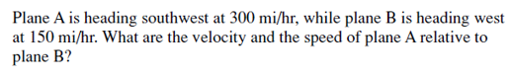

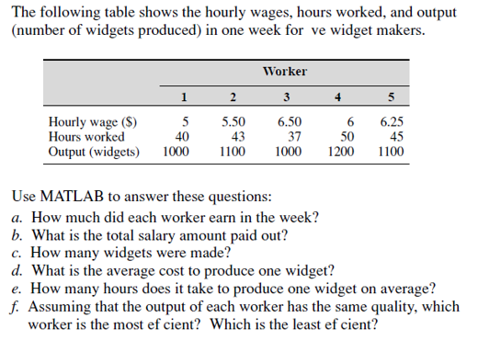

1. (2-variable function)

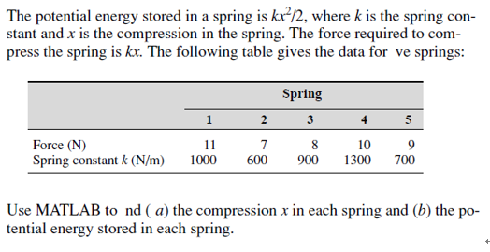

(4-7) (For & if statement) in textbook p.75 Exercise 2.25-2.28